

**iMobiTel**

**Imiboniselo yomsebenzisi**

yeyeOperating System yeAndroid

Contents

[1. Masiqale 1](#_Toc370735748)

[1.1 iIcons zeMobiTel 1](#_Toc370735749)

[1.2 Ngena 3](#_Toc370735750)

[1.3 Utshintsho lolwimi 3](#_Toc370735751)

[1.4 Phuma 4](#_Toc370735752)

[2 Ukusebenzisa iMobiTel App 4](#_Toc370735753)

[2.1 Ukulawula iinkcukacha zeshishini lakho 4](#_Toc370735754)

[2.1.1 Yongeza ishishini 5](#_Toc370735755)

[2.1.2 Bona iinkcukacha zeshishini 7](#_Toc370735756)

[2.1.3 Tshintsa iinkcukacha zeshishini 8](#_Toc370735757)

[2.1.4 Susa iinkcukacha zeshishini 9](#_Toc370735758)

[2.2 Ulawulo lweendawo zokuhlala 10](#_Toc370735759)

[2.2.1 Yongeza iinkcukacha zendawo yokuhlala 11](#_Toc370735760)

[2.2.2 Bona inkcukacha zendawo yokuhlala 13](#_Toc370735761)

[2.2.3 Tshintsha iinkcukacha zendawo yokuhlala 15](#_Toc370735762)

[2.2.4 Susa iinkcukacha zendawo yokuhlala 15](#_Toc370735763)

[2.3 Ulawulo lwamagumbi okulala 17](#_Toc370735764)

[2.3.1 Add RoomYongeza iinkcukacha zegumbi lokulala 18](#_Toc370735765)

[2.3.2 Bona iinkcukacha zamagumbi okulala 21](#_Toc370735766)

[2.3.3 Tshintsha iinkcukacha zamagumbi okulala 21](#_Toc370735767)

[2.3.4 Susa inkcukacha zegumbi lokulala 22](#_Toc370735768)

[3 Ukudibanisa (Synchronisation) 24](#_Toc370735769)

[3.1 Kudityaniswa njani 24](#_Toc370735770)

# Masiqale

## iIcons zeMobiTel

Zonke eziIcons zinomsebenzi wazo eziwenzayo xa umsebenzisi ezicofile:

|  |  |  |
| --- | --- | --- |
| MobiTel Icon |  | Action |
| C:\Users\g09m3478\Dropbox\Honours SysDev\Luminus Solutions Final Documentation\Design\App_icon.png | *iMobiTel App* | Ivula iMobiTel kwiFoni yeAndroid. |
|  | *Ekhaya* | Iphindisela umsebenzisi kwi Ekhaya. |
|  | *uSync* | Inxulumanisa iinkcukacha zeshishini, ezegumbi kunye noTeleWeaver. |
|  | *Faka* | Inkcukacha zeshishini, zendawo yokuhlala kunye nezegumbi zingongezwa kwi app. |
|  | *Tshintsha* | Inkcukacha zeshishini, kunye nezegumbi zingalungiswa kwi app. |
|  | *Susa* | Inkcukacha zeshishini, kunye nezegumbi zingasuswa kwi app. |
|  | *Gcina* | Utshintsho olwenziweyo kwi app luyagcineka kwiFoni for synchronisation. |
|  | *Rhoxa* | Utshintsho olwenziwe kwiapp lunga rhoxiswa. |
|  | *iGallery* | Udweliso lweFoto ezigciniweyo kwiFoni zinga jongwa xa umsebenzisi efuna ukukhetha/ukusebenzia enye yazo. |
|  | *iGallery yendawo yokuhlala* | Udweliso lweFoto zeAccomodation ezigciniweyo kwiMobiTel app. |
|  | *Thatha* | Umsebenzisi angacofa apha ukuze athathe iFoto entsha. iFoto entsha igcineka kwiGallery. |
|  | *iFoto entsha* | iFoto entsha ingakhethwa ngokucofa leIcon. |
|  | *Ibhari yeIcon* | Udweliso lweIcons ezingakhethwa/ezingasetyenziswa. |

**Itafile 1. iIcons zeMobiTel**

## Ngena

Xa uvula iMobTel app uzakubona iLogin screen. Kufuneka uqale ufake inkcukacha zakho zokungena (igama lomsebenzisi kunye nePassword) ukuze ukwazi ukusebenzisa leMobiTel app. Cofa kwi ndawo ethi *Faka igama lomsebenzisi* apho uzakufaka khona igama lakho lomsebenzi kunye nePassord ngezantsi. Ezi (igama lomsebenzisi kunye nePassword) zinkcukacha ozinikezwe nguReed House Systems. Xa ugqibile ufaka igama lomsebenzisi kunye nePassword ucofa kwiqhosha elithe ‘Ngena’.

Xa ilityeli lakho lokuqala usebenzisa leMobiTel app kufuneka kube kanti usendaweni ene Wi-Fi ukwenzela ukuba ukwazi ukungqinisisa igama lakho lomsebenzisi kunye nePassword. Ngapha koko uzakukwazi ukube kwityeli elilandelayo ukwazi ukuyisebenzisa le app ngaphandle kokuba ube kwindawo engenayo iWi-Fi, ngaphandle kokuba ufuna ukunxulumanisa iinkcukacha zakho kunye noTeleweaver.

## Utshintsho lolwimi

Xa ufuna ukutshintsha ulwimi leMobiTel app kufuneka ukhethe u**Lwimi** kwi bhokisi eyehlikayo. Ukwazi ukukhetha phakathi kweSixhosa kunye neSingesi.

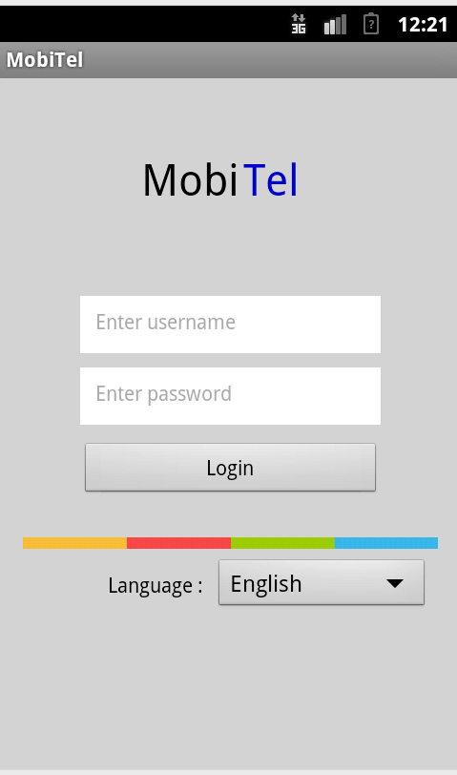

*Faka iPassword*

*Faka igama lomsebenzisi*

*Ibhokisi eyehlayo yokukhetha ulwimi*

*Iqhosa likaLogin*

*Igama leMobile Application*

## Phuma

Xa ufuna ukuphuma kwi MobiTel ucofa iIcon ethi **‘Phuma’**. Le icon ifumaneka phezulu kwicala lasekunene khona apha kule app, kwaye soloko ibonakala.

# Ukusebenzisa iMobiTel App

## Ukulawula iinkcukacha zeshishini lakho

Iinkcukacha zamashishini akho uzilawula kwikhusi lama **‘Shishini’**,kwaye likhusi lokuqla eli elithi livuleke emva kokuba ungenile kwiMobiTel App.

Kufuneka ucofe kwishishini ngokuthi ukhethe libe linye kulawo adwelisiweyo. Uzakuthi ukwazi ukongeza, ukulungisa kwaye nokususa iinkcukacha zamashishini akho.

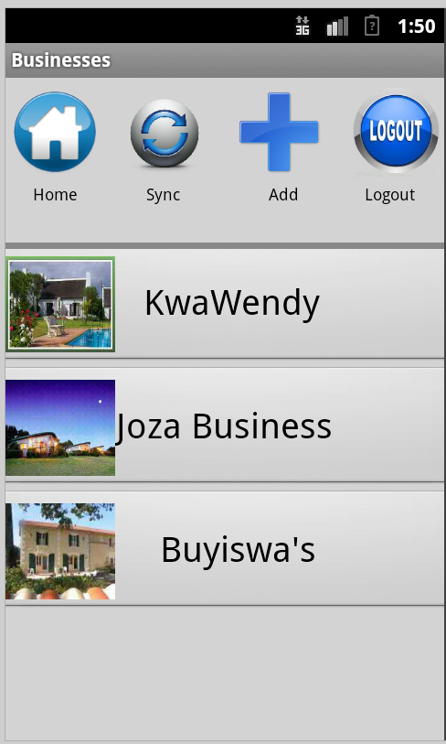

*Udweliso lwamashishini*

*Ibhari yeeIcon*

*Igama lekhusi*

*iFoto yeshishini*

### Yongeza ishishini

Ishishini elitsha ulifakela ngokuthi ucofe iIcon ethi “Faka”, efumaneka phezulu kwikhusi. Emva kokuba ucofe u”Faka” kuvela ikhusi elithi ‘Yongeza ishishini elitsha’

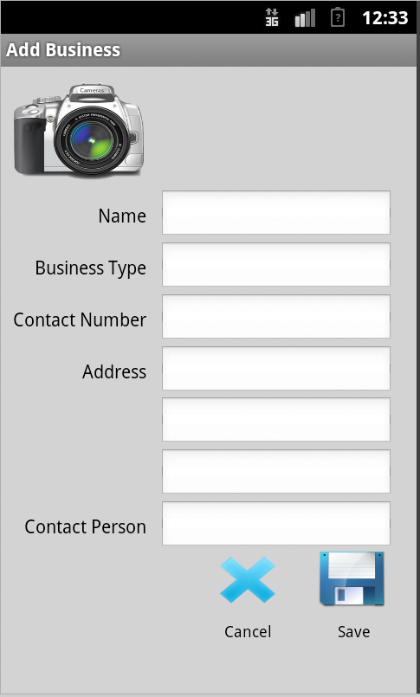

*Izikhewu zeenkcukacha zeshishini*

*iFoto yeshishini*

*Igama lekhusi*

Cofa kwizikhewu ezifanelekileyo (Igama, Uhlobo lweshishini, Inombolo yemfono-mfono, Idilesi kunye nomntu wonxibelelwano zinkcukacha ezidingekayo okanye ekunyanzelekileyo uba uzifake.

Ungafakela iFoto ngokuthi ucofe iIcon ye**Camera**, kwaye ungakhetha ukufaka ifoto kwenye yefoto esuka kwiGallery yeFoni okanye ufote entsha usebenzisa imfono-mfono yakho.

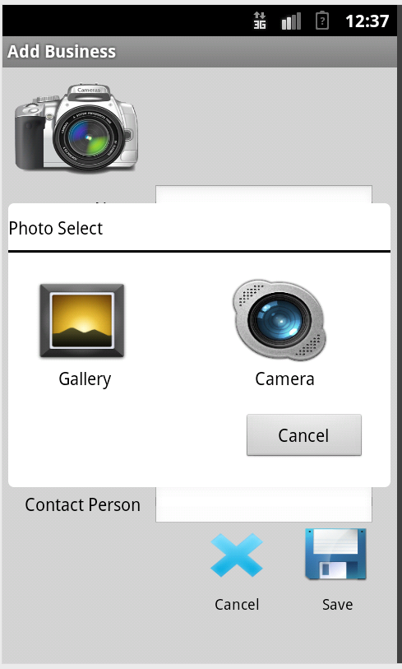

*Kheta iFoto kwenye yezi zilandelayo.*

*Igama lekhusi*

Xa sele uzifakile iinkcukacha zeshishini, cofa iIcon ka ‘**Gcina**’. Ikhusi lamashishini lizakuphinda livele kwakhona, libonakalisa ishishini osandula kulifaka kwiApp.

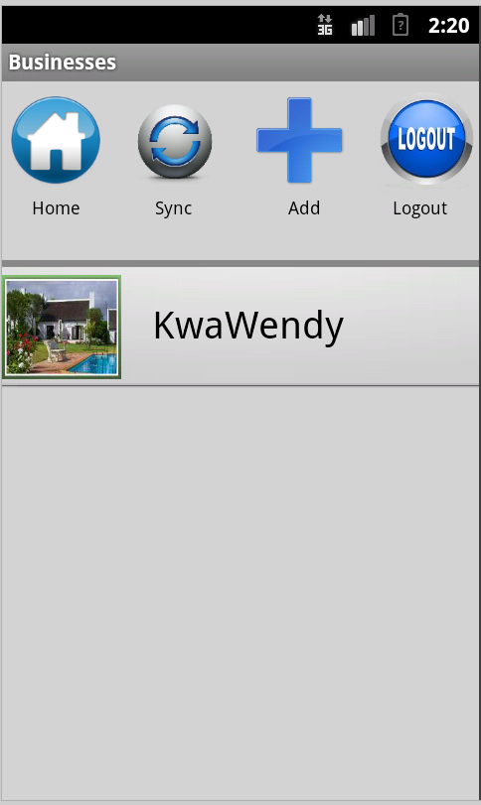

*Igama leshishini*

*iFoto yeshishini*

### Bona iinkcukacha zeshishini

Xa ufuna ubona inkcukacha zeshishini khetha ishishini ofuna ukubona iinkcukacha zalo kwikhusi lamashishini ngokuthi ucofe kwigama leshishishini okanye iFoto yeshishini.



*Igama leshishini*

*iFoto yeshishini*

Ikhusi leenkcukacha zeshishini liyavela apho khona kukho iinkcukacha zeshishini elo ubulikhethile.

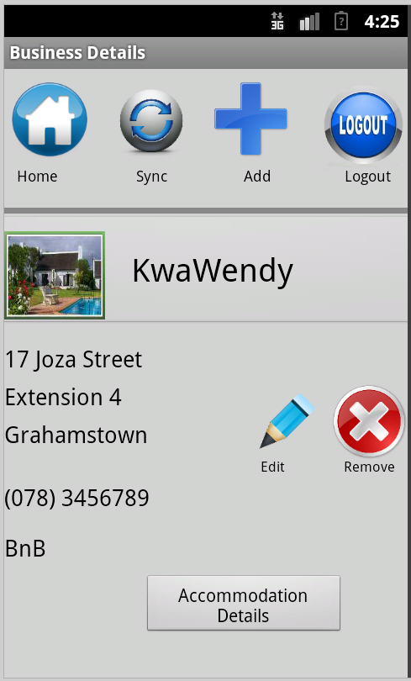

### Tshintsa iinkcukacha zeshishini

Iinkcukacha zeshishini zingalungiseka ngokuthi ucofe iIcon ka **‘Tshintsha’** kwikhusi lenkcukacha zeshishini. Kuzakuthi kuvele ikhusi loku **‘Tshintsha iinkcukacha zeshishini’**:

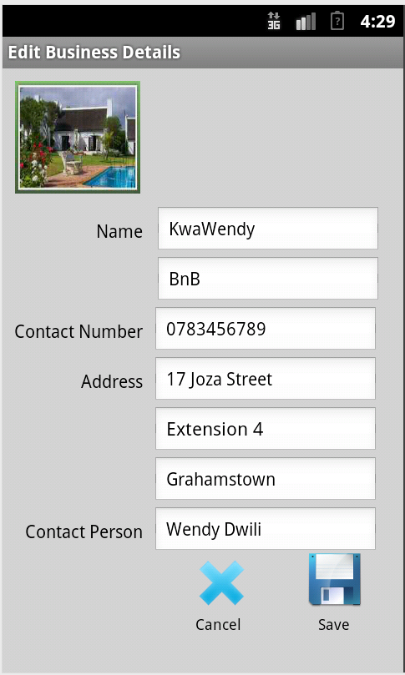

Xa sele uzilungisile iinkcukacha ungazigcina ngokuthi ucofe Iicon ka ‘Gcina’ ukuze iinguqu ozenzileyo zigcineke.

### Susa iinkcukacha zeshishini

Iinkcukacha zeshishini ungazisusa ngokuthi ucofe kwishishini elo ufuna ukulisusa. Ikhusi lenkcukaccha zeshishini lizakuthi livele, apho uzakuthi ucofe iIcon ethi **‘Susa’**. Kuzakuvela isexwayiso esibuzayo ukuba esibuzayo ukuba Uqinisekile ukuba ufuna ulisusa elishishini ulikhethileyo.

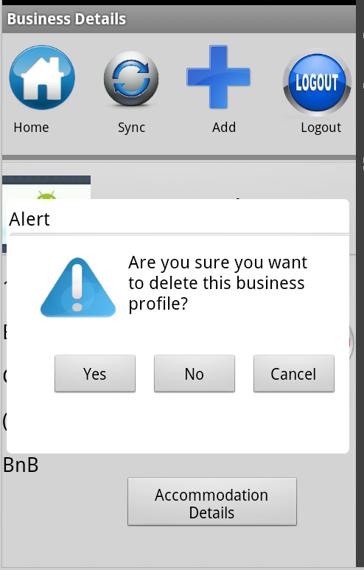

Ukuqinisekisa ukuba uyafuna ukulisusa elishishini ulikhethileyo, ucofa u **‘Ewe’**. Ngapha koko ukuba awufuni kulisusa eloshishini ucofa u **‘Hayi’**. Ukuze ususe ibhokisi yencoko ucofa u **‘Rhoxisa’**. Xa sele ukhethe u ‘Ewe’ ukuqinisekisa ukuba ufuna ukulisusa ishishini, ikhusi lamashishini lithi livele kwaye libe selingekho eloshishini ubulisusa.

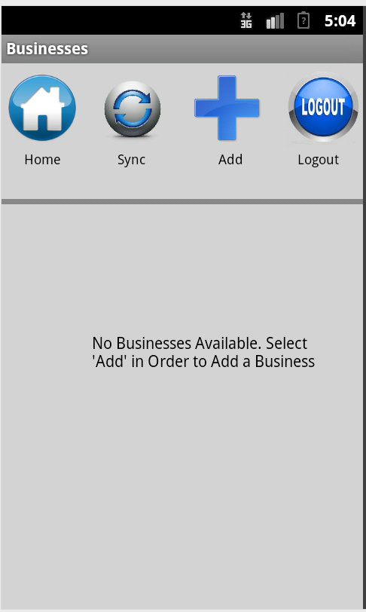

### Ulawulo lweendawo zokuhlala

Iinkcukacha zendawo yokuhlala zingalawulwa kwikhusi lweendawo zokuhlala. Xa usele uyikhethile indawo yokuhlala kwezo zidwelisiweyo ungakwazi ukulawula iinkcukacha zalondawo yokuhlala ngokuthi wongeze, utshintshe okanye ususe iinkcukacha zendawo yokuhala. Indawo yokuhlala ililungu leshishini kwaye kunjalo nje kufuneka ukuba uqale ukhethe ishishini apho khona ufuna ukulawula iinkcukacha zalo.

Ukuze ulawule iinkcukacha zendawo yokuhala ucofa iqhosha elithi ‘Iinkcukacha zendawo yokuhlala’ kwikhusi leenhkcukacha zeshishini elinxulumane nendawo leyo yokuhala ofuna ukuyilawula.



Ikhusi lweendawo zokuhlala lizakuthi livele.

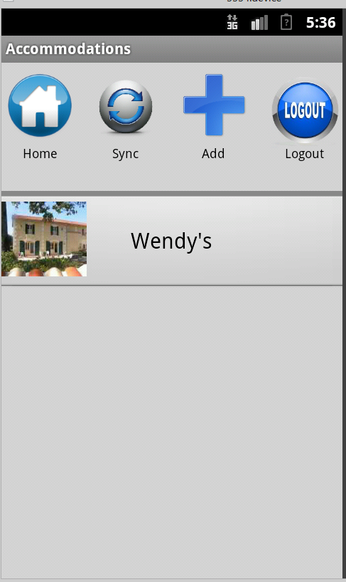

### Yongeza iinkcukacha zendawo yokuhlala

Iinkcukacha zendawo yokuhlala entsha zingongezwa ngokuthi ucofe iIcon ka **‘Yongeza’**, efumaneka phezulu kwikhusi.

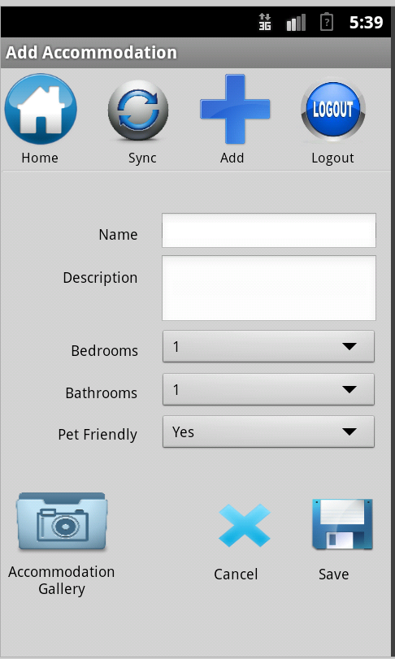

Faka iinkcukacha zendawo kwizikhewu ezifanelekileyo. Ifoto yendawo yokuhala ungayifakela ngokuthi ucofe iIcon ethi ‘**iGallery yendawo yokuhlala’**. Ibhokisi yencoko yendawo yokuhlala ithi ivele. Ungakhetha phakathi kokuba ufake ifoto esuka kwiGallery okanye uthathe ifoto entsha usebenzisa icamera yefoni. Ukhetha iIcon ethi **‘ifoto entsha’**.

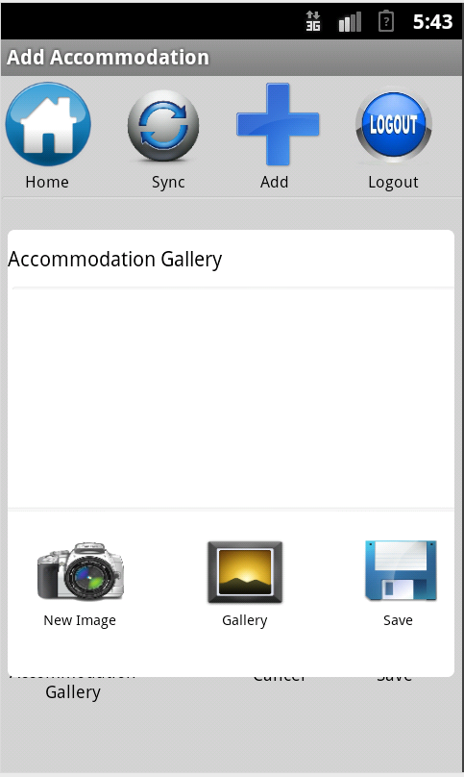

Ungafakela iifoto zendawo yokuhlala ezintathu kuphela. Kufuneka ucofe iIcon ka ‘Gcina’ xa sele uzikhethile, izakunyamalala ibhokisi yencoko kube sekuvela ikhusi lika **‘Yongeza iinkcukacha zendawo yokuhlala’** kwakhona.

Xa sele zonke iinkcukacha uzifakile, ucofa iIcon ka **‘Gcina’**. Kuzakuvela ikhusi leendawo zokuhlala, libonakalisa iindawo zokuhlala ozifakileyo kwiApp.

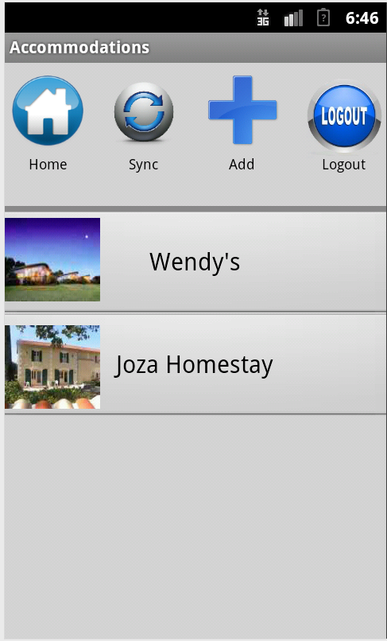

### Bona inkcukacha zendawo yokuhlala

Xa ufuna ubona inkcukacha zendawo yokuhlala khetha indawo yokuhlala ofuna ukubona iinkcukacha zalo kwikhusi leendawo zokuhlala ngokuthi ucofe kwigama lendawo yokuhlala okanye ifoto yendawo yokuhlala.



Ikhusi lweenkcukacha zendawo yokuhlala liyavela apho khona kukho iinkcukacha zendawo yokuhlala leyo ubuyikhethile.

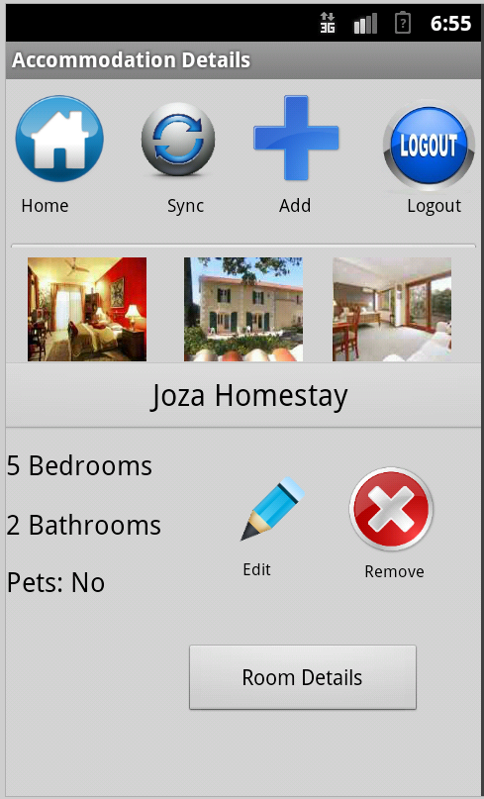

### Tshintsha iinkcukacha zendawo yokuhlala

Iinkcukacha zendawo yokuhlala zingatshintsheka ngokuthi ucofe iIcon ka **‘Tshintsha’** kwikhusi lwenkcukacha zendawo yokuhlala. Kuzakuthi kuvele ikhusi loku **‘Tshintsha iinkcukacha zendawo yokuhlala’**:

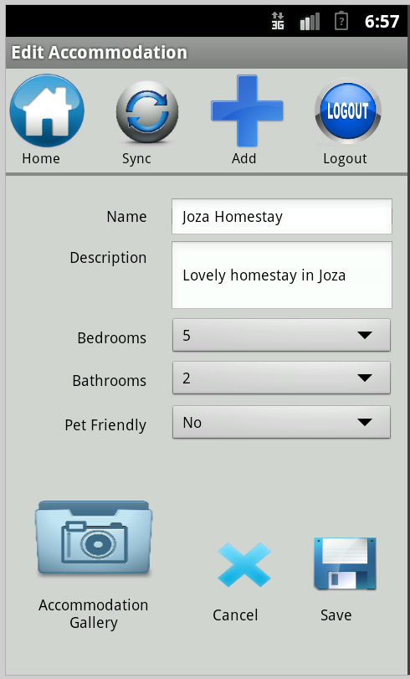

Xa sele uzilungisile iinkcukacha ungazigcina ngokuthi ucofe Iicon ka ‘Gcina’ ukuze iinguqu ozenzileyo zigcineke.

### Susa iinkcukacha zendawo yokuhlala

Iinkcukacha zendawo yokuhlala ungazisusa ngokuthi ucofe kwindawo leyo yokuhlala ofuna ukuyisusa. Ikhusi lenkcukaccha zendawo zokuhlala lizakuthi livele, apho uzakuthi ucofe iIcon ethi **‘Susa’**. Kuzakuvela isexwayiso esibuzayo ukuba esibuzayo ukuba Uqinisekile ukuba ufuna ukuyisusa lendawo yokuhlala oyikhethileyo.

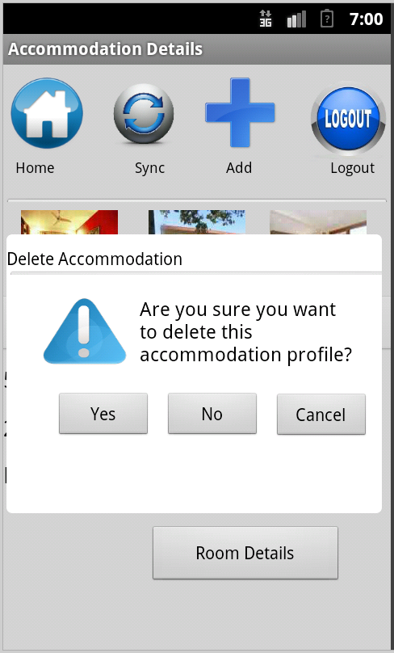

Ukuqinisekisa ukuba uyafuna ukuyisusa lendawo yokuhlala uyikhethileyo, ucofa u **‘Ewe’**. Ngapha koko ukuba awufuni kuyisusa lendawo yokuhlala u **‘Hayi’**. Ukuze ususe ibhokisi yencoko ucofa u **‘Rhoxisa’**. Xa sele ukhethe u ‘Ewe’ ukuqinisekisa ukuba ufuna ukyisusa indawo yokuhlala, ikhusi lwendawo zokuhlala lithi livele kwaye ibe sele ingekho lendawo yokuhlala uyisusileyo.



### Ulawulo lwamagumbi okulala

Iinkcukacha zamagumbi okulala zingalawulwa kwikhusi lweendawo zokuhlala. Xa usele uyikhethile indawo yokuhlala kwezo zidwelisiweyo ungakwazi ukulawula iinkcukacha zalondawo yokuhlala ngokuthi wongeze, utshintshe okanye ususe iinkcukacha zendawo yokuhala. Indawo yokuhlala ililungu leshishini kwaye kunjalo nje kufuneka ukuba uqale ukhethe ishishini apho khona ufuna ukulawula iinkcukacha zalo.

Ukuze ulawule iinkcukacha zegumbi lokulala ucofa iqhosha elithi ‘Iinkcukacha zendawo yokuhlala’ kwikhusi leenhkcukacha zeshishini elinxulumane nendawo leyo yokuhala ofuna ukuyilawula.



Xa sele ucofe iqhosha elithi **‘Inkcukacha zamagumbi okulala’**, ikhusi lamagumbi okulala lizakuthi livele.

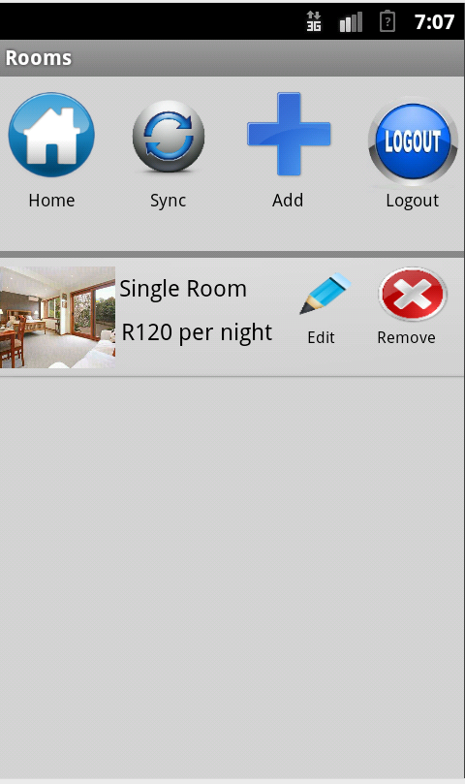

### Add RoomYongeza iinkcukacha zegumbi lokulala

Iinkcukacha ezintsha zegumbi lokulala zingongezwa ngokuthi ucofe iIcon ka **‘Yongeza’**, efumaneka phezulu kwikhusi. Ikhusi lika **‘Yongeza igumbi lokulala’** lithi livele.

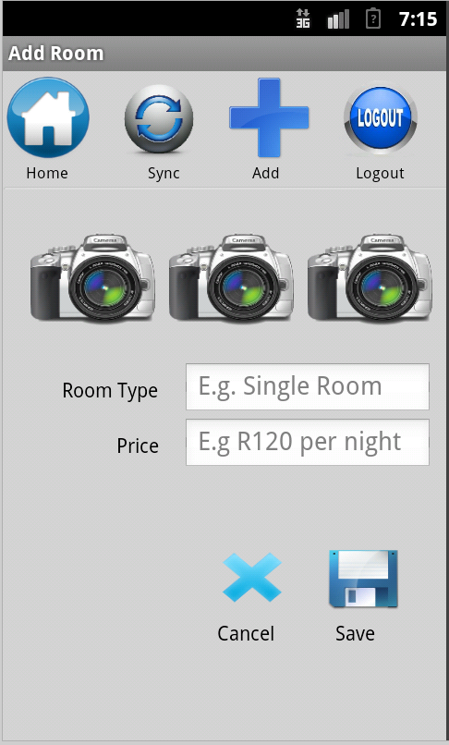

Faka iinkcukacha zegumbi lokulala kwizikhewu ezifanelekileyo. Ifoto yegumbi lokulala ungayifakela ngokuthi ucofe iIcon ethi yeCamera. Ibhokisi yencoko izakuthi ivele apho khona ungakhetha ukufaka ifoto ekwiGallery yefoni okanye ukuthatha ifoto entsha usebenzisa ifoni. yendawo yokuhlala ithi ivele. Ungakhetha phakathi kokuba ufake ifoto esuka kwiGallery okanye uthathe ifoto entsha usebenzisa icamera yefoni.

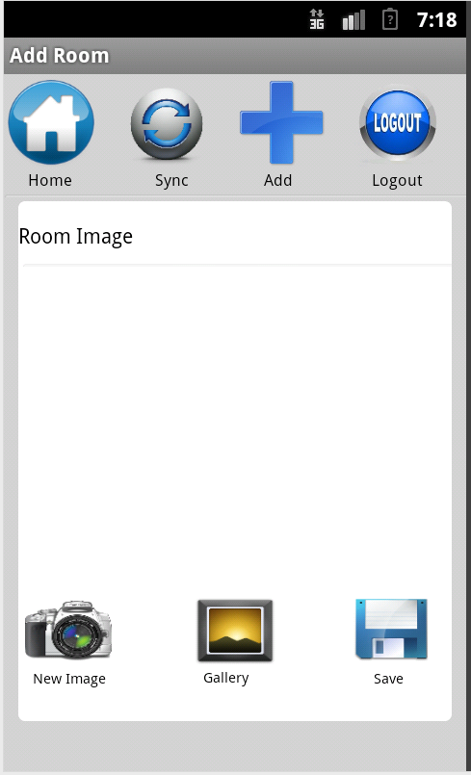

Ungafakela iifoto zegumbi lokulala ezintathu kuphela. Kufuneka ucofe iIcon ka ‘Gcina’ xa sele uzikhethile, izakunyamalala ibhokisi yencoko kube sekuvela ikhusi lika **‘Yongeza iinkcukacha zegumbi lokulala’** kwakhona.

Xa sele zonke iinkcukacha uzifakile, ucofa iIcon ka **‘Gcina’**. Kuzakuvela ikhusi lamagumbi okulala, libonakalisa amagumbi okulala owafakileyo kwiApp.

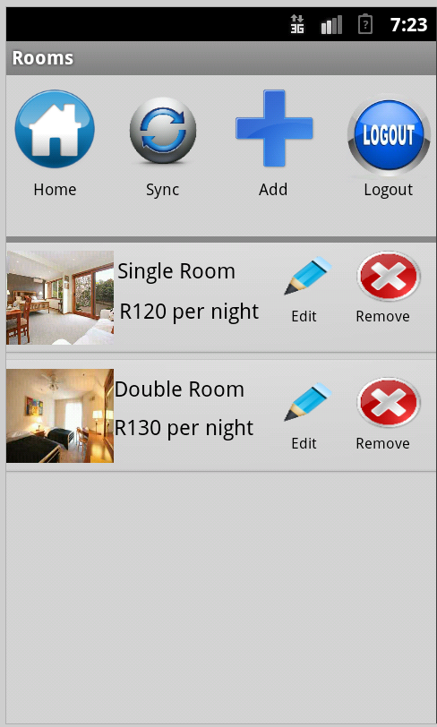

### Bona iinkcukacha zamagumbi okulala

Xa ufuna ubona inkcukacha zendawo yokuhlala ungenza njalo kwikhusi lwamagumbi okulala.



### Tshintsha iinkcukacha zamagumbi okulala

Iinkcukacha zegumbi lokulala zingatshintsheka ngokuthi ucofe iIcon ka **‘Tshintsha’** kwikhusi lwenkcukacha zamagumbi okulala. Kuzakuthi kuvele ikhusi loku **‘Tshintsha iinkcukacha zamagumbi okulala’**:

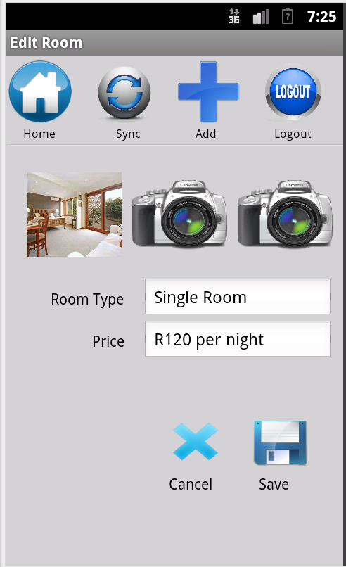

Xa sele uzilungisile iinkcukacha ungazigcina ngokuthi ucofe Iicon ka ‘Gcina’ ukuze iinguqu ozenzileyo zigcineke.

### Susa inkcukacha zegumbi lokulala

Iinkcukacha zegumbi lokulala ungazisusa ngokuthi ucofe iIcon ethi **“Susa”** kwikhusi lwamagumbi okulala. Xa sele ucofe u**Susa** kuzakuvela isexwayiso esibuzayo ukuba uqinisekile ukuba ufuna ukusua iinkcukacha zegumbi lokulala elo.

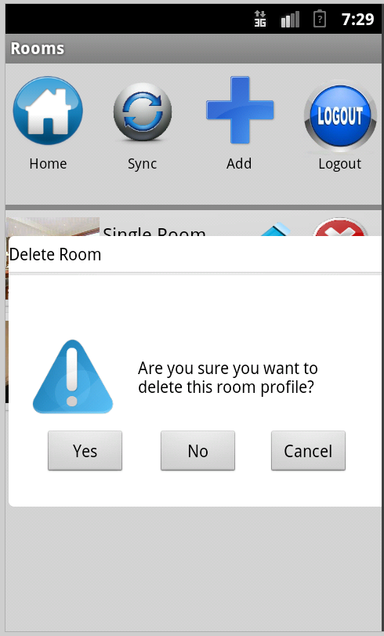

Ukuqinisekisa ukuba uyafuna ukulisusa igumbi lokulala elo ulikhethileyo ucofa u **‘Ewe’**. Ngapha koko ukuba awufuni kulisusa elo gumbi lokulala ukhetha u **‘Hayi’**. Ukuze ususe ibhokisi yencoko ucofa u **‘Rhoxisa’**. Xa sele ukhethe u ‘Ewe’ ukuqinisekisa ukuba ufuna ukulisusa elogumbi lokulala, ikhusi lwamagumbi okulala lithi livele kwaye libe sele lingekho igumbi elo ulisusileyo.

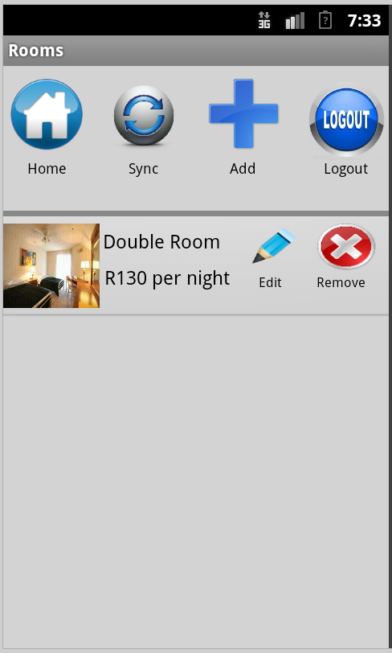

# Ukudibanisa (Synchronisation)

## Kudityaniswa njani

Ukuze ube uyakwazi ukuthumela iinkcukacha zakho zeshishini, indawo yokuhlala kunye namagumbi okuhlala kwi website yeTeleweaver, kufuneka uzidibanise zonke iinkcukacha zakho kunye noTeleweaver. Ukwenze njalo kufuneka kube kanti unxulumene ne Wi-Fi kwindawo leyo ukuyo.

Ukudibanisa iinkcukacha zakho ucofa kwiIcon ethi ‘**Sync**’ efumaneka phezulu kwi bhari yeLogo kumakhusi angundoqo kwiApp

Xa sele umcofile u ‘Sync’ kuzakuvela ibhokisi yencoko enesexwayiso esichazayo ukuba iinkcukacha zakho zidibanisekile.

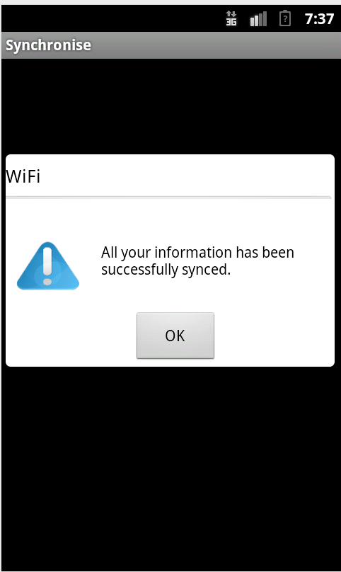

*Ibhokisi yencoko eqinisekisayo ukuba iinkcukacha zidibanisekile*

Xa sele ucofe iqhosha lika ‘Kulungile’ apho kuzakuthi kwandule ngovela ikhusi le ‘Shishini’. Ukuba sele iinkcukacha uzidibanisile kwaye kube kungekho nkcukacha zintsha ezidinga ukudityaniswa, kuvele ibhokisi yencoko ikuxelela njalo ukuba akho nkcukacha zidinga ukudityaniswa.

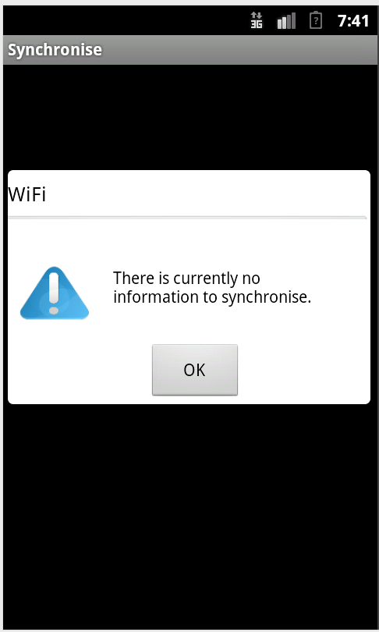

*Ibhokisi yencoko eqinisekisa ukudibanisa kweenkcukacha*